Prepare one number with any name say ‘we’ in **binding.component.ts**

we:number=700;

now bind the data in **binding.component.html**

inside the table add the foolowing lines

 <!--Style Binding Example-->

            <td [style.font-weight]="we">{{p.price}}</td>

            <!--Style Bindings Ends here-->

Save and check the output

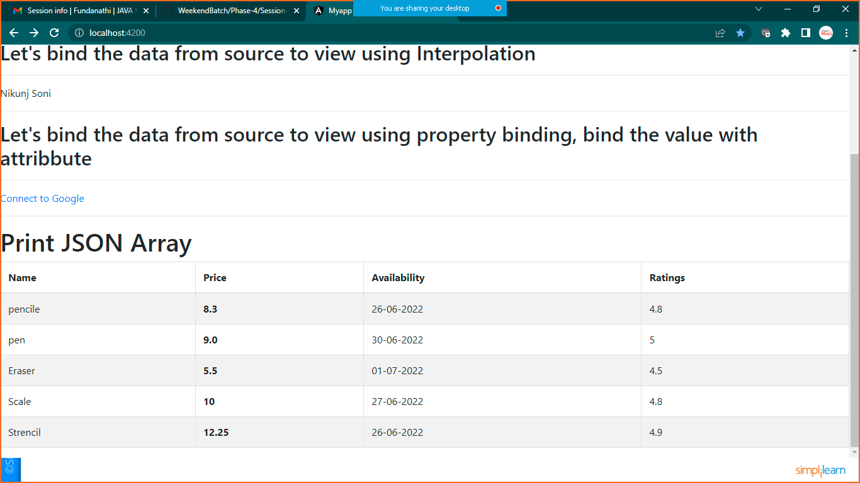

**EVENT BINDING**

Prepare one button and div in **binding.component.html**

<div class="container">

    <button class="btn btn-primary" (click)="show()" >SHow Div</button>

    <div *ngIf="flag" style="background-color: yellowgreen">

        This is My Div and You Have Implemented Event Binding

    </div>

</div>

Now go to **binding.component.ts** file

flag:boolean=false;

  show(){

    this.flag=!this.flag;

  }

Save and check the output